
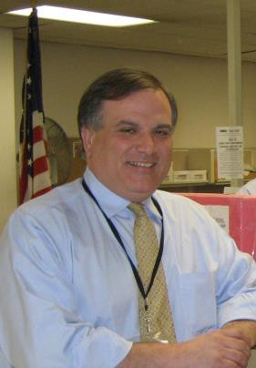





Getting a U.S. Passport just got easier.
Westchester County Clerk Timothy Idoni’s community outreach staff can take your photo and process your passport application when they visit:
Cortlandt Town Hall
1 Heady Street
Friday, June 22nd, from 11 a.m. – 2 p.m.
What do you need to apply?
Proof that you are a United States citizen such as an original or certified birth
certificate or original naturalization certificate.
A valid driver’s license or a government issued identification card.
The total fee is $145 for adult applicants (16 and over) and $115 for child
applicants (under 16). The $35 processing portion of the fee can be paid by check, money order or credit card. The remainder of the fee, $110 for adults and $80 for children MUST be paid by check or money order made out to the U.S. Department of State. We cannot accept cash on the Mobile Office. Applications will also be accepted for the U.S. Passport Card for land and sea border travel, only. The fee for adults is $65.00 ($30 to US Dept. of State), for children, the fee is $50.00 ($15 to US Dept. of State).
We can take your passport photo for an additional $10.00 fee ($7.00 for seniors).
If you need your passport in about 2-3 weeks, expedited service is an additional
$60.00 per passport application. For Overnight Return Delivery Service, add an additional fee of $15.89 for each application, payable to US Department of State.
Questions? Call 914-995-3082 or visit www.WestchesterClerk.com, where you can
also download the Application for U.S. Passport DS-11.
Why apply now?
Routine passport applications are now taking approximately 6 weeks. For an additional charge, expedited service will result in your obtaining your passport in about 2-3 weeks. But only in emergency circumstances can a passport application be processed more quickly, so do not delay.
Office of the Westchester County Clerk, 110 Dr. Martin Luther King Jr. Blvd., White Plains, NY 10601 Open Monday through Friday from 8 a.m. until 5 p.m. / (914)995-3080/www.westchesterclerk.com
Please Note: We cannot accept the Application for Passport by Mail Form DS-82. Applicants must renew by mail for passports issued within the last 15 years, if applicants were at least 16 years old when passport was issued, and for applicants whose name remains unchanged since passport was issued.

If your ADULT passport is expired OVER 5 years, you can apply with us by bringing your old passport. If UNDER 5 years, you must renew by mail submitting the DS-82 form.

